

EE 380 Probability, Statistics, and Stochastic Modeling

Lab 1: Relationship Between Binomial and Normal Distributions

Date Turned In: Date: February XX, 20201

Tu/Th 5:30 pm - 8:15 pm

Group X

Instructor: Dr. Taggart

Students in Last Name Alphabetical Name First

Last Name, First Name , short number X

Picture color and clearly shows your face, and other if you want

Last Name, First Name , short number X

Picture

Last Name, First Name , short number X

Picture

Last Name, First Name , short number X

Picture

Last Name, First Name , short number X

Picture

Last Name, First Name , short number X

Picture

Comment: Put in your own disttool plots

**Part 1 of Lab 1.**

**Introduction: ____________________________**

Use the MATLAB disttool tool to show relationship between the binomial and normal distributions. (Working with the pdf)

There are 100 coin flips of a fair coin. Plot this using the disttool. This should look like immediately below. Please add titles and other labels on this graph using the disttool if you can.

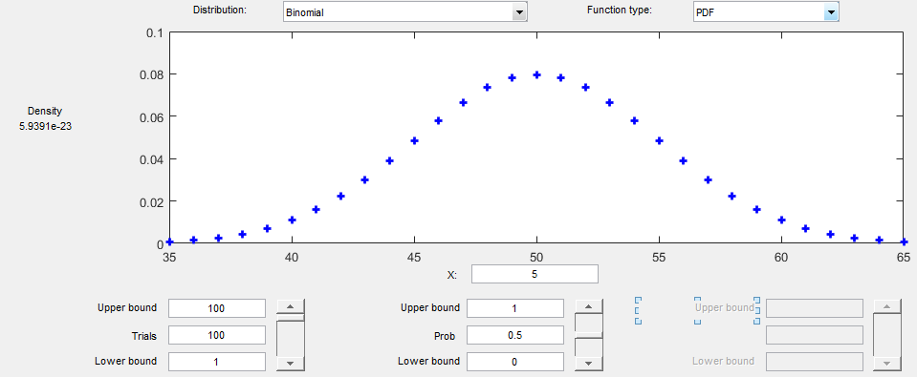

How note that relationship between the binomial and normal distributions as noted below.

Note that the binomial distribution is discrete while the normal distribution is continuous. Note also that the binomal and normal distribution only agree at discrete number of heads on the x axis.

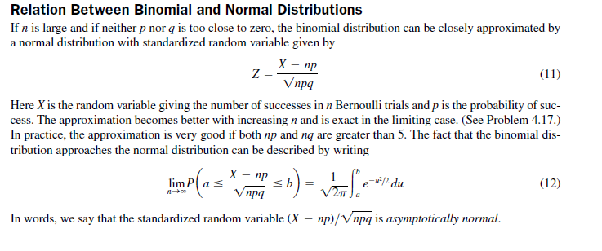

Now make a plot as indicated below using the disttool. Indicate what the mean and standard deviation you must use to make the normal plot below. Add labels to the plots using the disttool.

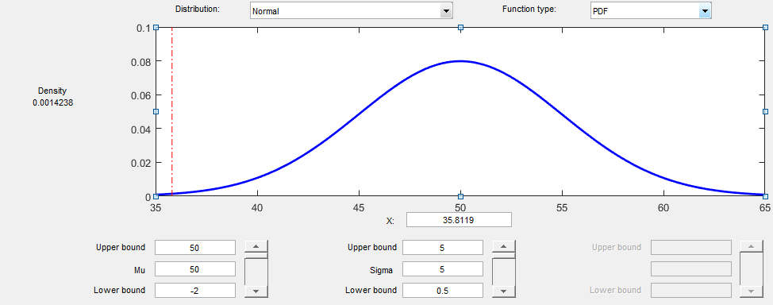

**Discussion of Results**

**Any Interesting Findings on disttool**

**Conclusion**

>>>>>>>>>>>>>>>>>>>>>>>>>>>>>>>>>>>>>>

Part 2 of Lab 1.

**Introduction**

Use MATLAB script to make plots to independently check the disttool of the above result using the equations below instead of disttool (two plots). Also, make a MATLAB plot that plots both the binomial and normal distributions on the same curve (a third plot). Also label all your curves in detail using ML S/W. 

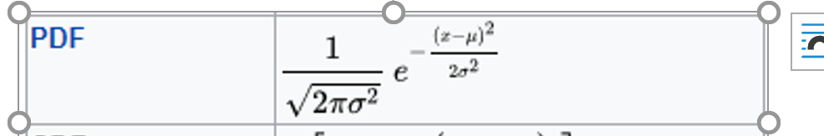

Mean =50

Standard deviation of 5.

**Discussion of Results**

**Conclusion**

**ML Code**

<<<<<<<<<<<<<<<<<<<<<<<<<<<<<<<<<<<<<<<<<<<<<<<<<<<<<<<<<<<<<<<<<<<<

**Introduction**

Part 3 Do the same thing as Part 1 but for CDF using the disttool. Comment: For binomial and Normal distribution.

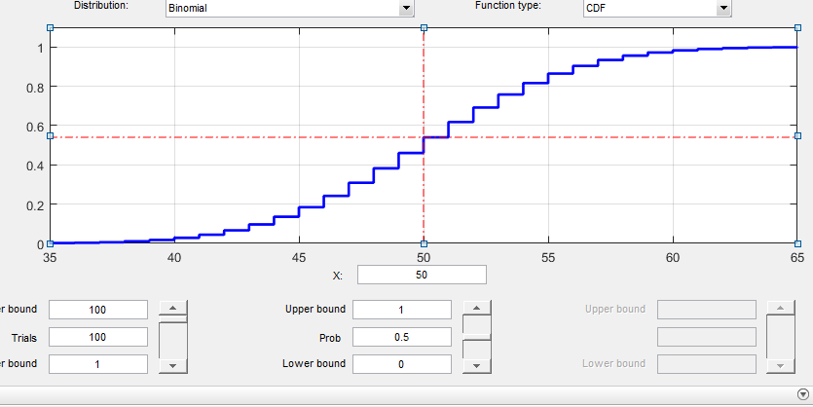

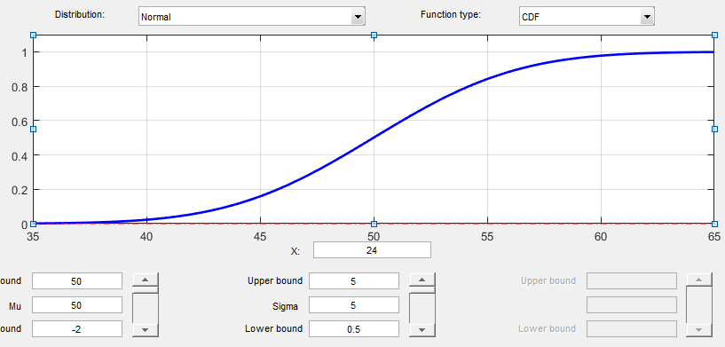

**Discussion of Results**

**Any Findings on disttoll**

**Conclusion**

>>>>>>>>>>>>>>>>>>>>>>>>>>>>>>>>>>>>>>>>>>>>>>>>>>>>>>>>

**Introduction**

Part 4 . For CDF, Use MATLAB script for cdf to make plots to independently check the above result using the equations below instead of disttool. Use MATLAB script to make plots to independently check the disttool of the above result using the equations below instead of disttool (two plots). Also, make a MATLAB plot that plots both the binomial and normal distributions on the same curve (a third plot). Also label all your curves in detail using ML S/W.

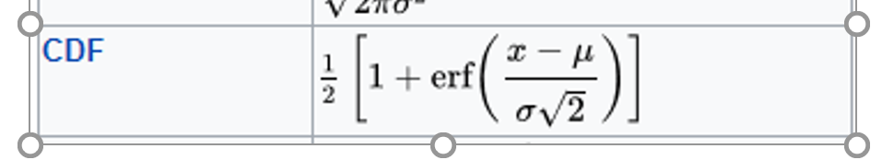

**Figure out an approach for CDF of binomina**l

**Discussion of Results**

**Conclusion**

**ML Code**

>>>>>>>>>>>>>>>>>>>>>>>>>>>>>>>>>>>>>>>>>>>>>>>>>>>>>>>>>>>>>>>>>>>>>>

Part 5. Extra Credit: Repeat part 2 using C++

Part 6. Extra Credit: Repeat part 2 using Python

Part 7. Extra Credit Use Excel in an innovative manner to do Part 2.

Part 8. Extra Credit: Repeat part 2 using Minitab